Paper Title (UJSSH-Paper-Title)

Mohd, Azri¹ & Mc, Arthur^{2*}
Example: Mohd (family name), Azri (first name), Davidson (family name), Nick (first name)

¹Organisation Address, City, Postcode, Country

²Organisation Address, City, Postcode, Country

*Corresponding author email:

Received xx Month 202x, Revised xx Month 202x, Accepted xx Month 202x, Available online xx Month 202x

To link to this article: https://doi.org/10.53797/ujssh.v1i1.1.2022
Abstract: An abstract is obligatorily required. The first sentence explains the concept of the area of research and background details. Then, the next sentences describe the research problem or objectives and the field of study. The following sentences illustrate the methodology and usage of materials to carry out the research. Then, the primary results and crucial findings must be emphasized. Eventually, a summary is given for the conclusions. The abstract length can be equivalent to article length.
Keywords: Keyword 1, keyword 2, keyword 3 (Commonly the number of keywords up to three until five)

1. Introduction
To write an introduction, if necessary, add vocabulary in a box with similar font size along with the following papers. The paragraphs proceed from this and divided with headings, subheadings, pictures, and formulae only. Also, do use English (United Kingdom) solely for the reference and citation style according to APA 6th edition. Please ensure that at least 30% of the list references consists of papers from the last five years back.

Structure (Heading 2)
The manuscript must be in Microsoft Word. It also needs to be prepared in direct printing format by applying the given CRC Microsoft Word. Figures and tables must be inserted along and must be attached. You are advised to use standard fonts in your manuscript as much as possible. Particular fonts, the East Asia fonts such as Japanese, Chinese, Korean and others may lead to issues during the preparation phase Therefore, you are encouraged to practice Microsoft Word's 'spellchecker' feature to prevent unwanted errors. Then, follow this direction in writing the paper: Title, Authors, Affiliations, Abstract, Keywords, Main Text (also the figures and tables), Acknowledgements, References, and Appendix. Compile acknowledgements at the end of the article in a different category, and avoid it on the title page, as a footnote or other.
List of bullets can be used based on the following format:
• First point
• Second point
• And others
Make sure you comply with 'Els-body-text' style. It is a that format should be included to finish the bulleted list, mainly for large blocks of text. Kindly do not change the formatting and style templates established in this template manuscript. As shown in the example, papers with a trim size of 210x 280 mm should be provided in a double-column format that is acceptable for printing straight to the paper. Avoid putting the number on the front page, as the page numbers for the preprints and the cases are added separately. Put a straight line in between the paragraphs. Complete the needed style templates are given with the appropriate name attached in the "MS Word Template" file, e.g. choose 1. Els1st-order-head for the document heading as your first order, els-abstract-text for abstract text, etc.

- Tables (Heading 3)
Arabic numerals should be numbered on all tables. Every table must have a description explaining the table of contents. The headings will be listed out above tables, justified on the left. Within a table, only horizontal lines should apply to determine the headings of the column from the table body, up and below the table. Tables need to be inserted in text and should not be given independently. Table 1 is a sample that might be helpful to the authors.
Table 1. Example of a table
The example of a column heading | A (t) | B (t)
And an entry | 1 | 2
And another entry | 3 | 4
And another entry | 5 | 6

Structure of References
You need to list the references at the end of the manuscript. Unless this is required, do not start them on a new page. Reference should follow the standard of an APA 6th edition and must be specified in alphabetical order, font 10, and not bold (reference styles). Authors will make sure that each reference in the text included in reference list, and conversely. Specify references in the text by (Richard, Harold, & Lipton, 2018), or (Steve & Whitney, 2020).
Few examples of how you should list your references are given in the 'References' section at the end of this guide that can help to compile the reference list based on the appropriate format and font size.

Section Headings
The section headings (Heading 1 style) must be left-justified, bold, capitalized, and numbered consecutively along to the first letter beginning in Introduction. Heading 2 style sub-section headings also need in a similar format as headings, numbered 1.1, 1.2, etc., and left-justified, with second and next lines indented. Before a page or column break, every heading must at least have three text lines as follows. Except for the last page, make sure that the text area is not empty. Another level of the subheadings should not be bold and in the same style as 1.1.1.

Generic Guidelines
Skip hyphenation at the last line. Symbols which denote vectors and matrices must be written in bold. Names of the scalar variable will usually appear in italics. Refer to the SI unit when describing weight and measures. Provide with a glossary or specified when first stated for all of non-standard abbreviations or symbols.

File Naming and Delivery
Do label the documents to this name 'Article acronym submission year authorslastname'. Give all sources and PDF files to Guest Editor.
The filenames for the artwork will follow the syntax "aabbbbb.ccc," that is:
•a: artwork component type
•b: manuscript reference code
•c: standard file extension

Groups of elements:
•gr: figure
•pl: plate
•sc: scheme
•fx: fixed graphic

Footnotes
Do avoid footnotes as much as you can. Consecutive superscript letters1 should be used to denote necessary footnotes in the text. Single spaced footnotes should be written at the footer of page that are listed and also divided from the primary text with a single line space extending at the foot of the column, in a smaller type size (7 pt). The Els-footnote style for footnote text accessible in Microsoft Word.
Also do not change template margins as this can cause the footnote to effect on the range of printing.

Illustrations
The whole numbers must be numbered by Arabic numerals (1, 2, 3...) and each of it must have a description. Every images, schemas, charts and diagram are known as figures. Line drawings need to scan with high quality or real electronic output. Low performing scanning is inappropriate. Figure is required to be included in the text and should not be presented independently. The figures must be coded correctly in Microsoft Word data. Figures are recommended in PNG, JPEG, GIF, etc. format. Letters and symbols are identified as part of the figure, either in a caption or legend given. Figures should be located as near as possible to the first reference, whether at top or bottom page. Kindly remember all figures must in 300 DPI resolutions because they produce successful output.
The number of figure and caption must remain in 9 pt under the illustration and left-justified [Note: one-line captions based in length lower than the column width (or maximum or oblong typesetting width)]. As the additional information and guidelines to guide you send high-quality artwork, you are advised to view the example on the website: http://www.elsevier.com/artworkinstructions. Artwork does not have any text on the next to the primary body of the document. If both figures images fit together, however, these can be placed side by side to reduce the area. As reference, refer Fig. 1.


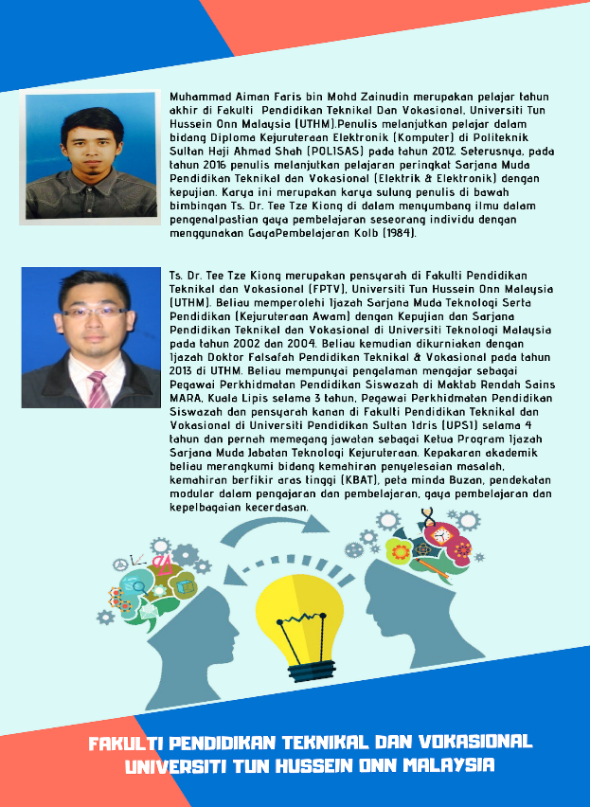

Figure 1. (a) first picture; (b) second picture

Equations
Equations and formulae are required in Math type format and numbered accordingly in parentheses with Arabic numerals on the right side of page (as specifically mentioned in the paper). A single space must separate it even from the main text.
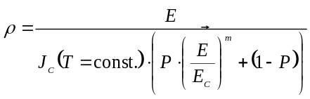 (1)

Online License Transfer
Before the article is written, every author expected to fulfil the Procedia's exclusive license transfer agreement that they able to do it the Internet. This transfer arrangement allows Elsevier to secure the writers' copyrighted content but should not hand over the proprietary rights of the writer. The transfer of copyright protects the exclusive right of reproduction and dissemination of the work, including copies, photographic prints, microfilm or other related reproductions and translations. Author is bound to seek permission from the copyright owner to reuse every figure in respect of the right of copyright.
Acknowledgement
Acknowledgement, Appendix and Reference heading (Acknowledgement style) need to left-justified, font 10, bold, with a capitalization of the first letter and without numbers. The subsequent text proceeds as the standard form.

Conflict of Interest
All authors should disclose any personal and/or financial relationships with others or organizations that may improperly influence their paper. A conflict-of-interest statement should be provided in the manuscript file immediately before the References section. Case there are no Conflicts of Interest, so report "The authors declare no conflicts of interest".
Appendix A: An Example
Before the References section, authors must include an appendix section. All appendices are required to have headings in style as above. It needs to be arranged automatically from A, B, C etc.
References
Damien, T. (2018). Behavior of HTR fuel elements in aquatic phases of repository host rock formations. Nuclear Engineering & Design, 54(1), 20-29. [Example for Journal]
Garry, B. (2020). Creative ways of being. In Morss, J.R., Stephenson, N. & Rappard, J.F.H.V. (Eds.), Theoretical issues in psychology: Proceedings of the International Society for Theoretical Psychology 2019 Conference (3-12). Sydney: Springer. [Example for Paper in conference proceedings in print]
Matthew, T.D. & Allen, R.F. (2016). How to prepare an electronic version of your article. In B. S. Jones & R. Z. Smith (Eds.), Introduction to the electronic age (281–304). New York: E-Publishing Inc. [Example for Chapter in book]
Ramesh, S. (2017, June). Factors influencing Student Success. Paper presented at the IEEE Symposium on 3D User Interfaces. doi: 10.1200/vr.2018.023 [Example for Paper in conference proceedings online: Electronic database]
Simon, Y., Jr. & Wayne, R.C. (2020). The elements of style (3rd ed.). New York: MacMillan. [Example for Book]
Van der Geer, J., Hanraads, J.A.J. & Lupton, R.A. (2000). The art of writing a scientific article. Journal of Science Communication, 163(2), 51-59. https://doi.org10.1015/j.tree.2012.05.090 [Example for Online Journal]

